Shopware Export

Documentation of SourceCode & Working Process

This document is all you need to understand how the export function from DuG data to Shopware works. It will tailor it to your needs and learn the basic elements that has been used to develop the program.

Please do not update or edit the program before reading the document/completely understand its functionalities. Consulting with the author or user of the program is recommended

# Abstract

This program automatically checks/reads the log data which is generated by DuG export generation program. If an export is successfully finished, this program automatically realizes the change and performs its own operation. Operations include – read the export data from the “archiv” folder, make the article data in the shopware-suitable format (template-name.csv), at the end upload the data online (via secure FTP connection) in the ‘import_cron’ folder, and finally import the data to shopware via “cron job”.

# Information on Log-data

Log data includes all the information regarding an export e.g export start-time, end-time, error-logs (warnings) information of article import. Here is a screen shot of the log data – which says an export operation was finished on 28-06-2018 at 12:42pm. This information is very useful for the shopware export program.

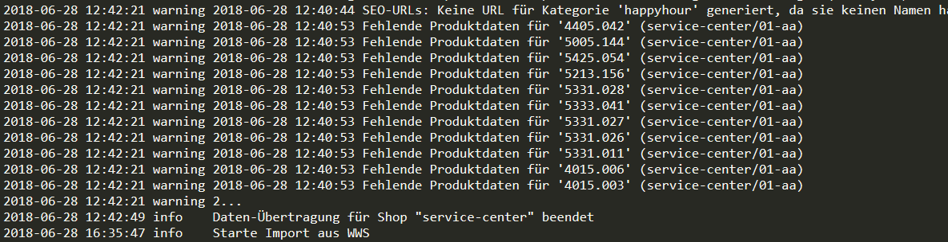

Log data can be found in the following folder-path:

***G:\VS\DG\Ishop\Websale\websale8_shop-service-center\log\***

The name of the log data is dynamically generated. Which means it there is no unique name of the log data rather it has a unique name structure. The name of data consists 4 digits of numbers (e.g 1806.log). First two digits are resembling the year and last two digits are resembling the month of the current year. Therefore, logically, the name of the log data changes automatically on every month.

# Information on Export-data

After a successful export operation, a set of data are generated in the following folder:

***G:\VS\DG\Ishop\Websale\websale8_shop-service-center\data-exchange\archiv***

Here a screen shot of the “archiv” folder, where two folders are generated by the export.

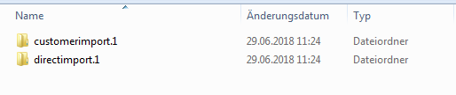

This program has nothing to do with the customerimport.1. This program only concerns the directimport.1, where contains all the information on article. Here is the inside view of this folder. Among these folders “01-aa” and “amountupdate” data are necessary for the export.

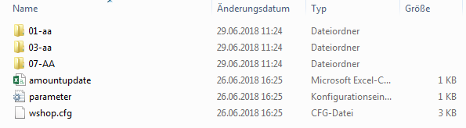

This pictures shows the contents of “01-aa” folder.

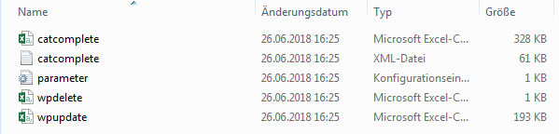

The significance of each folder will be discussed/described later in this document.

# Table of Contents / Inhalt

1. Methods documentation / Methodendokumentation
2. Programmer documentation / Programmiererdokumentation
3. Installation documentation / Installationdokumentation
4. User documentation / Benutzerdokumentation
5. Data documentation / Datendokumentation
6. Developer documentation / Entwicklungdokumentation
7. System documentation / Systemdokumente

# 1. Methods & Algorithms